PRESCHOOL FIELD OFFICER PROGRAM
What is the Preschool Field Officer (PSFO) program?
The PSFO program is designed to provide practical advice and support to Victorian government funded kindergarten services to build their capacity to provide for the inclusion, access, learning and development, and meaningful participation of children with additional needs.
PSFOs provide a range of supports including information, resources, program strategies, contributing to the educator’s identification of a child’s additional needs, coaching of the educator, modelling specific strategies, and identification of referral pathways. These supports assist educators to build their confidence, knowledge and skills to plan and deliver an inclusive kindergarten program that is responsive to the needs of children with additional needs.
Who is eligible for the PSFO service?
All Victorian funded kindergarten programs are eligible to receive PSFO service to support the access, inclusion and participation of children with additional needs in a kindergarten program. This includes children enrolled in Four-Year-Old Kindergarten, funded Three-Year-Old Kindergarten and Early Start Kindergarten.
Children with Additional Needs
The PSFO program defines children with additional needs as children presenting with developmental concerns. Developmental concerns may be associated with any area of children’s development, from language delays or challenging behaviours through to children with multiple disabilities. Children with additional needs resulting from trauma are also eligible for a PSFO referral.

If a child’s development is supported by a National Disability Insurance Scheme (NDIS) or early childhood intervention continuity of support provider, it is expected that the early childhood educator in consultation with the family will seek support from this provider in the first instance. Early childhood intervention professionals can provide strategies that support the child to participate meaningfully in learning experiences with their peers that are consistent with strategies being implemented across other settings where the child spends their time.
Is there a cost for the PSFO service?
PSFO program is available at no cost within the universal service to all state funded kindergarten services.
Who provides the PSFO service?
The Department of Education and Training funds community service organisations and local councils to provide PSFO services across the state. The service utilises an outreach model, enabling the PSFO to provide services within the kindergarten program and environment.
What are the qualifications of a PSFO?
As the role of the PSFO is to build the capacity of kindergarten educators, a PSFO must be a degree qualified early childhood educator with experience in planning and delivering high quality inclusive kindergarten programs.

Do PSFOs work with families?
PSFOs work within the context of the kindergarten program. The PSFO does not directly deliver intervention to a child within the kindergarten setting but acts as a consultant and coach to the early childhood educator. This approach may involve direct contact with the child and family in the kindergarten setting, however, this work is done in collaboration with and through the early childhood educator in a manner that respects the educator’s ongoing relationship with the child and family. The PSFO may directly observe the child in the kindergarten environment and contribute to the educator’s assessment of the child’s capabilities as well as their learning and development needs. PSFOs also assist the educator to identify and link families to a range of supports available and assist the educator’s program planning for the child in the kindergarten program.

As the PSFO service supports early childhood educators to respond to the individual needs of a child with additional needs, the early childhood educator is required to obtain informed consent from parents/guardians/carers for PSFO involvement with their child, prior to PSFO assistance.
Can parents contact the PSFO program?
Parents of children in funded kindergarten programs who have concerns regarding their child’s development should discuss these with their child’s early childhood educator in the first instance. Where a parent directly contacts the PSFO program, the PSFO will liaise with the relevant educator to progress the referral.
What does capacity building of early childhood educators mean?
The PSFO capacity building approach supports kindergarten educators to:
- gain the knowledge and skills to confidently implement practices and provide programs that are responsive to the individual abilities, interests and needs of children with additional needs in an inclusive kindergarten environment
- see themselves as having both the responsibility and capability to plan for all children in the kindergarten program and that it is not only experts with specialist skills who can provide support for the learning and development of children with additional needs
- respond to parents’ concerns regarding their child’s development.
For more information visit, Preschool Field Officer Program.

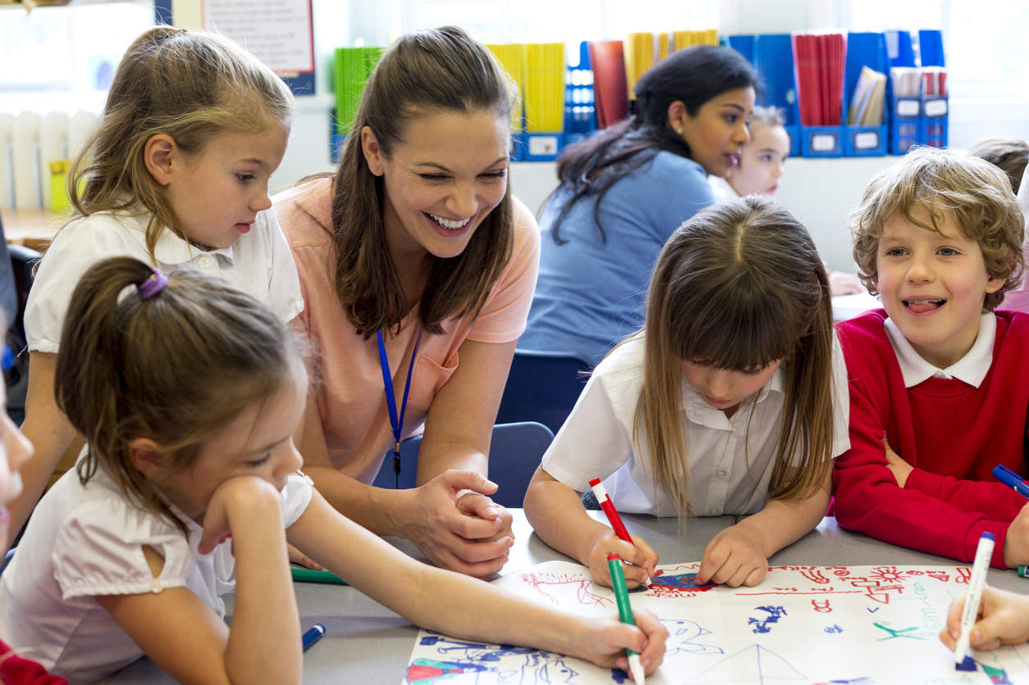

Other supports available to kindergarten programs
The PSFO role complements a range of assistance provided by other specialist services and kindergarten supports including:
- Professional development of early childhood educators
- Quality and regulatory early childhood education and care supports
- Early Years Management organisations
- LOOKOUT Education and Support Centres
- Koorie Engagement Support Officers (KESOs) and Koorie Education Coordinators (KECs)
- Early Childhood Intervention professionals
- Kindergarten Inclusion Support (KIS) program
- Access to Early Learning (AEL)
- School Readiness Funding
  - SRF Allied Health Support

What is the difference between supports offered through the PSFO program and School Readiness Funding (SRF)?
The PSFO service is available to funded kindergarten programs in response to an early childhood educator requesting assistance in supporting the inclusion of an individual child with additional needs. Strategies provided by PSFO’s enhance early childhood educator’s capacity to plan and respond to the individual child’s needs in a kindergarten environment.

SRF is additional funding to address educational disadvantage and is targeted to the educational needs of the group of children attending a kindergarten service. SRF provides access to a range of programs and supports that build the skills and knowledge of educators and families to support children’s learning and development in the three priority areas: communication (language development), wellbeing (social emotional), and access and inclusion.
For more information visit, School Readiness Funding

